CHAPTER ONE: INTRODUCTION

1.1 Background of the Study
The election of student leaders is a long-standing feature of university governance. It gives the student body a formal voice in institutional affairs and prepares students for wider civic participation. At Puntland State University (PSU), Galkaio Campus, this responsibility is exercised through two categories of election. Each of the university's six faculties elects a single faculty representative, and the entire student body elects one university-wide leader, the Student Body President (known locally as the Gudoomiye). Eligibility follows enrolment: a student votes in the election of the faculty to which they belong, and every student is entitled to vote in the university-wide Student Body President election.
These elections are presently conducted by manual means. Voting takes place on paper at designated polling points on the campus, where each voter attends in person, is verified against the register, and deposits a marked ballot. The completed ballots are afterwards counted by hand, and the outcome is declared by the university. Although this procedure is well understood and requires no specialised infrastructure, it places considerable demands on both the electorate and the administration. Its reliance on physical attendance at a single location, within a single day, restricts participation and concentrates the administrative effort at the stage most prone to error, the manual count (Thiga et al., 2018).
The conditions under which such a process operates have changed appreciably in recent years. Digital connectivity in Somalia has widened to the point where, by the beginning of 2025, an estimated 10.7 million individuals, close to 55 percent of the population, were internet users, alongside approximately 11.3 million mobile connections (Kemp, 2025). Access remains uneven and is lower in rural districts than in urban centres (Ministry of Communications and Technology, 2025), yet the student population of a campus-based university is now, in the main, reachable through personal mobile devices. This shift provides the practical basis for reconsidering the manner in which student elections at PSU are conducted.
Against this background, the present study develops an Online Voting System for Puntland State University, Galkaio Campus. The system is a web-based application through which a registered student authenticates remotely and casts a vote from a personal device during an officially defined election period, without attending a polling point in person. It is conceived as an institution-specific solution rather than a general-purpose platform, designed around the university's own electoral model, its two tiers of faculty and university leadership, and the operational conditions of the Galkaio Campus.
The system is intended to retain the essential guarantees of a credible election while removing the constraints of the manual process. Access is governed by passwordless authentication, in which a single-use code is delivered to each registered student by electronic mail, so that only eligible members of the university may take part. Each student is presented with only the ballots for which they are eligible, that is, the ballot of their own faculty together with the university-wide Student Body President ballot. The principle of one person, one vote is enforced at the level of the server rather than the interface, and each ballot is recorded in a manner that allows a student's participation to be confirmed without their choice being disclosed. Aggregate results are made available to the election committee in real time, and the integrity of the recorded ballots can be independently verified.
Adopted for use at PSU, a system of this kind offers clear advantages over the current arrangement. It relieves students of the cost and time entailed in travelling to the campus to vote, thereby widening access and supporting higher participation. It reduces the administrative burden of printing, staffing, and manual tallying, and it shortens the interval between the close of voting and the announcement of results. Because counting is performed automatically, the principal source of error and dispute in the manual process is removed (Thiga et al., 2018). The combination of secret balloting with verifiable records further addresses the two requirements that any trustworthy voting system must satisfy, namely the confidentiality of the individual vote and the verifiability of the collective result (Keeler & Smyth, 2026). These benefits are consistent with wider evidence that electronic voting can reduce electoral costs, accelerate counting, and enable participation independent of location (Achieng & Ruhode, 2013; Jafar et al., 2022).
This study accordingly concerns the design, implementation, and evaluation of that system. The chapter proceeds by stating the problem the system is intended to solve, defining the objectives and research questions that guide its development, and setting out the scope of the work together with the terms used throughout the thesis.

1.2 Statement of the Problem
An effective student election should enable every eligible student to cast a single secret vote at minimal cost, and should yield a result in which the university community can place confidence. It should extend the opportunity to participate to the whole electorate rather than to those able to attend the campus on a prescribed day, and it should allow the outcome to be produced and checked without undue delay.
The manual process currently in use at PSU falls short of these expectations in several respects. Because voting requires attendance in person at a campus polling point on a fixed day, students incur expense and forgo time in order to participate, and a portion of the eligible electorate abstains where the cost of attendance is disproportionate or the timing is inconvenient, with a corresponding reduction in turnout. The administration, in turn, must bear the recurring effort of producing ballots, staffing polling stations, and counting votes by hand. The manual count is the least reliable element of the process, being slow, susceptible to error, and open to dispute over the manner in which the tally was reached (Thiga et al., 2018). Results are not available promptly, and the process affords the ordinary voter little visible assurance that the count was conducted correctly.
Although electronic and online voting systems have been shown to address such difficulties in other settings, the available solutions are not suited to the particular circumstances of PSU. A substantial body of recent work is directed towards large-scale public elections or towards elaborate cryptographic and blockchain-based architectures whose cost and complexity cannot be justified for a single university (Jafar et al., 2022), while the systems reported from comparable institutions in the region were devised for their own contexts and, in several instances, retained voting within the campus rather than permitting it remotely (Thiga et al., 2018). None is constructed around the two-tier model of faculty representatives and a Student Body President, the scale, or the local constraints that characterise elections at PSU. The problem addressed by this study is therefore the absence of a secure, institution-specific system that enables eligible PSU students to vote remotely within an official window while guaranteeing one vote per student, preserving ballot secrecy, and producing an auditable result. The study responds to this problem by designing and implementing such a system for Puntland State University, Galkaio Campus.

1.3 General Objective
The general objective of this study is to design and implement a secure, web-based online voting system that enables eligible students of Puntland State University, Galkaio Campus, to vote remotely in faculty and university leadership elections during an official election period.

1.4 Specific Objectives
The specific objectives of the study are:
- To analyse the requirements of PSU's faculty and university leadership elections and model them as a software system.
- To design a database and system architecture that scope each ballot correctly, so that a student sees only the faculty ballot for the faculty in which they are enrolled, together with the university-wide Student Body President ballot.
- To implement passwordless authentication using an emailed one-time password, so that only registered students can log in without relying on passwords.
- To enforce one vote per student per election on the server, and to record each ballot so that the voter's identity remains separate from the voter's choice.
- To provide the election committee with a real-time dashboard of aggregate results and a means of verifying that the recorded ballots have not been altered.
- To test and evaluate the system against its security and functional requirements.

1.5 Research Questions
The study is guided by the following research questions:
- What are the functional and security requirements of an online voting system for PSU's faculty and university leadership elections?
- How can the system scope ballots so that each student votes only in the elections for which they are eligible?
- How can the system authenticate students without passwords while keeping unauthorised users out?
- How can the system guarantee one vote per student per election while keeping each ballot secret and still auditable?
- To what extent does the implemented system meet its security and functional requirements when tested?

1.6 Hypothesis
This study is a design-and-build (system development) project rather than an experimental or statistical one. Its aim is to construct a working system and to evaluate it against defined requirements, not to test a relationship between measured variables. For that reason the study does not state a formal statistical hypothesis. The proposition it sets out to demonstrate is that a web-based system can enable PSU students to vote remotely while preserving one vote per student, maintaining ballot secrecy, and keeping the result auditable.

1.7 Significance of the Study
The outputs of this study are of value to several groups within and beyond the university.
For students, the system removes the requirement to travel to the campus in order to vote, together with the associated expense and loss of time. Participation becomes accessible to students who live at a distance or whose timetables conflict with a fixed polling day, and broader access may in turn raise turnout, so that elected leaders more fully reflect the student body.
For the university and its election committee, the system reduces the recurring labour of printing ballots, staffing polling points, and counting by hand. It shortens the time required to obtain a result and lowers the likelihood of a counting error, which is the aspect of the present process most exposed to mistakes and dispute (Thiga et al., 2018). The real-time dashboard enables the committee to monitor participation while voting is open, and the audit and integrity facilities provide a means of demonstrating that the recorded result was not tampered with.
For the wider university community, a process that keeps each ballot secret while allowing the result to be checked supports confidence in student leadership elections (Keeler & Smyth, 2026). This consideration is significant, since institutions have in some cases withdrawn from electronic voting where confidence was lacking (Achieng & Ruhode, 2013), and a system that is auditable by design is better placed to establish it.
For future students and developers, the design and its documentation provide a reference for building secure voting systems, and comparable systems, within a Somali university setting, where locally suited examples remain scarce.

1.8 Scope of the Study

1.8.1 Content Scope
The study covers the analysis, design, implementation, and testing of a web-based voting system for PSU student leadership elections. The system handles administrator-managed student records, election and candidate setup, passwordless student login, ballot scoping, vote casting, one-vote enforcement, ballot secrecy, a real-time results dashboard for the committee, and audit logging. Candidates are registered by the administrator; students do not nominate themselves. Results are made available to the election committee within the system and are announced officially by the university outside it, so the system does not publish results to students or to the public.

1.8.2 Geographical Scope
The system is developed for Puntland State University, Galkaio Campus, and its student leadership elections. Because voting is conducted over the web, an eligible student may vote from any location with internet access during the open window, although the user base is confined to registered PSU students and the university's election administrators.

1.8.3 Time Scope
The study is carried out as a final-year undergraduate project between June and August 2026. The system is intended for use in PSU student leadership elections held within and after that period.

1.8.4 Limitations
The system depends on students having an internet-connected device, access to the email account registered for them, and functioning email delivery during the election window. To reduce the effect of an email failure, the design allows an administrator to issue a one-time login code manually for a student who cannot receive the emailed code, but reliable connectivity and email delivery remain outside the control of the study. Voter turnout likewise depends on students' willingness and device access, which the system can support but cannot guarantee.

1.8.5 Delimitations
The study deliberately excludes advanced cryptographic voting schemes, such as homomorphic encryption and blind signatures, which were judged unnecessary and difficult to defend for a single-developer project at this scale (Jafar et al., 2022). It is confined to PSU student leadership elections and does not address other kinds of election, and it does not include a public results page, since official results are announced by the university outside the system.

1.9 Operational Definitions of Terms
Online voting system. The web-based system developed in this study, through which eligible PSU students authenticate and cast votes remotely during an official election window.
One-time password (OTP). A single-use numeric code, valid for a short period, that is emailed to a student and entered to log in, in place of a password.
JSON Web Token (JWT). A signed token issued to a student after login and sent with later requests to prove that the student is authenticated and to carry the student's role.
Faculty representative. The student elected to represent one faculty; each of the six faculties elects one, and only students enrolled in that faculty may vote for that position.
Student Body President. The single university-wide student leader elected by all PSU students; known locally as the Gudoomiye.
Ballot scoping. The rule by which the system presents a student with only the elections for which that student is eligible, that is, the ballot of the student's own faculty together with the Student Body President ballot.
Ballot secrecy. The property that the system can confirm that a student voted without recording, or being able to reconstruct, how that student voted.
Vote receipt. A record that a given student voted in a given election, held separately from the ballot itself and used to prevent a second vote.
Vote. A record of a choice made in an election, stored without any link to the student who made it, so that the choice cannot be traced back to a voter.
Audit log. A stored record of key actions in the system, such as opening an election or casting a vote, used to review activity without exposing any voter's choice.
Role-based access control (RBAC). The scheme by which the system grants each user only the actions permitted for that user's role, such as student, administrator, or auditor.
Turnout. The proportion of eligible students who voted in a given election, reported to the committee as an aggregate figure.

1.10 Conceptual Framework
The conceptual framework describes how the inputs to the voting system are processed into the outcomes the system is intended to deliver. The inputs are the data and configuration the system requires: the student records held by the administrator (email, student identifier, faculty, and name), the elections and their time windows, and the candidates attached to each election. The process is the sequence the system carries out. A student authenticates with an emailed one-time password, the system determines which ballots that student is eligible for, the student casts a vote, and the system records the vote once and in secret while updating the aggregate tally. The outputs are the results the system produces: remote voting for eligible students, one vote per student per election, ballots that are secret yet auditable, a real-time tally for the committee, and a lower cost in money, time, and effort than the current paper process. Within this framing, the inputs and the process constitute the independent side that the study controls through design, while the outputs are the dependent outcomes by which the system is judged against its objectives.
Figure 1.1 presents these three stages and the flow between them. 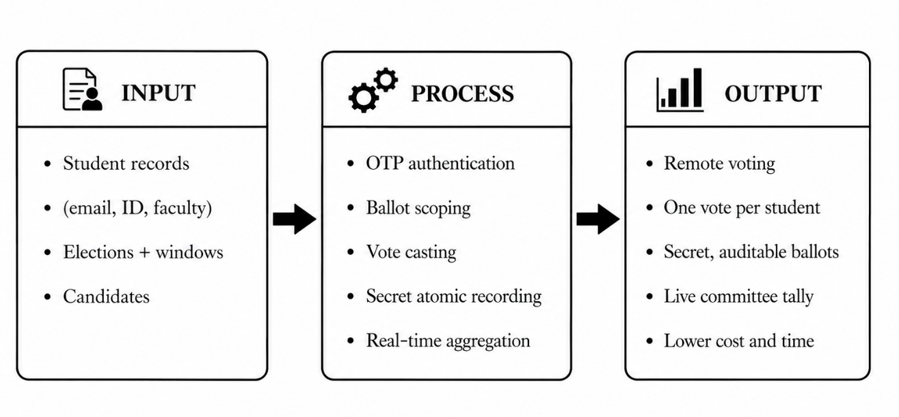
Figure 1.1 Conceptual Framework of the PSU Online Voting System

References
Achieng, M., & Ruhode, E. (2013). The adoption and challenges of electronic voting technologies within the South African context. International Journal of Managing Information Technology, 5(4), 1-12. https://doi.org/10.5121/ijmit.2013.5401
Jafar, U., Ab Aziz, M. J., Shukur, Z., & Hussain, H. A. (2022). A systematic literature review and meta-analysis on scalable blockchain-based electronic voting systems. Sensors, 22(19), 7585. https://doi.org/10.3390/s22197585
Keeler, P., & Smyth, B. (2026). Secrecy and verifiability: An introduction to electronic voting [Preprint]. arXiv. https://arxiv.org/abs/2602.12398
Kemp, S. (2025). Digital 2025: Somalia. DataReportal. https://datareportal.com/reports/digital-2025-somalia
Ministry of Communications and Technology. (2025). Somalia digital inclusion policy. Federal Government of Somalia. https://moct.gov.so/en/wp-content/uploads/2025/08/Somalia-Digital-Inclusion-Policy_High-Level-Policy-document.pdf
Thiga, M., Chebon, V., Kiptoo, S., Okumu, E., & Onyango, D. (2018). Electronic voting system for university student elections: The case of Kabarak University, Kenya. In 2018 IST-Africa Week Conference (IST-Africa) (pp. 1-11). IEEE.

